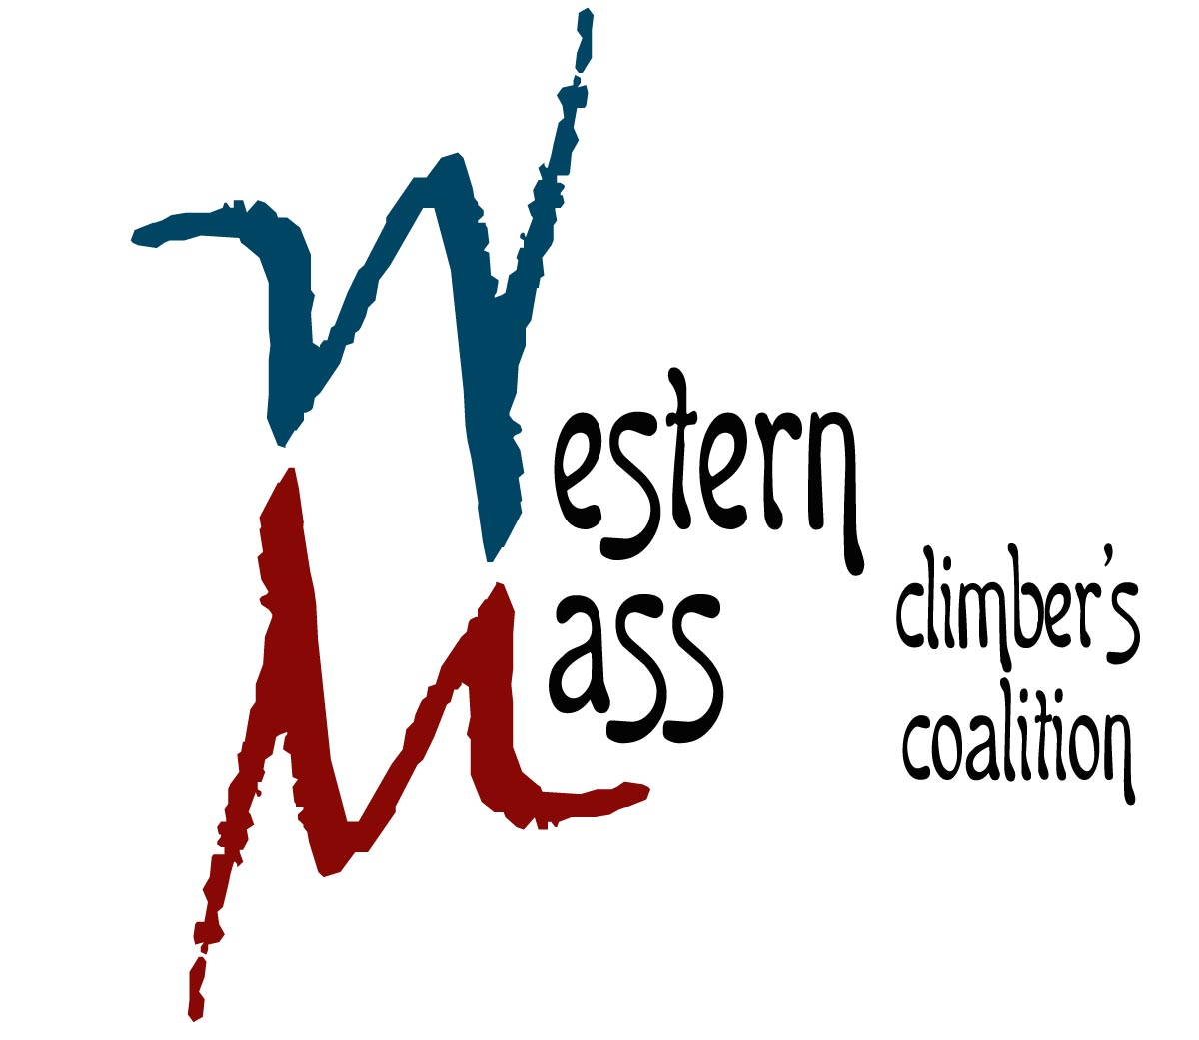
25 Parkview Drive
South Hadley, MA 01075
413.493.1974 www.climbgneiss.org

October 3, 2014

Lady Killegrew Cafe
440 Greenfield Rd.
Montague, MA 01351

Dear Mr. Majka

On behalf of the Western Massachusetts Climbers’ Coalition (a registered 501c3, EIN #81-0548355), I would like to take this opportunity to thank you for supporting our organization and helping to protect and preserve climbing resources in Massachusetts.

Your generous donation of a weekend of food, beverage and wait-staff to our Western Mass Rendezvous event (September 19th-21st, 2014) was an extraordinary gift that helped us reach our fundraising goals!

Again, thank you for your support and we hope to see your sexy ass at the cliffs soon.

Sincerely,
Peter Clark

President
Western Massachusetts Climbers’ Coalition

